Wireless Bluetooth Headset Bluetooth Connection Tutorial Storyboard
Narration: …how to connect your own wireless bluetooth headset to your cell phone.  Title Slide: NONE  Music: None  Motion: Speak to the camera. | Start of the video.
Narration: …for the demonstration.  Title Slide: NONE  Music: None  Motion: Take out the demo headset and cell phone and show it in front of the screen | 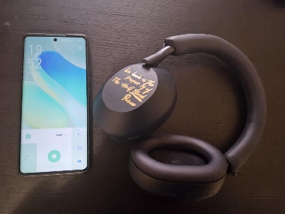
Narration: ... go to Bluetooth . Scroll down to Available device  Title Slide: NONE  Music: None  Motion: Open Settings -> Bluetooth. | 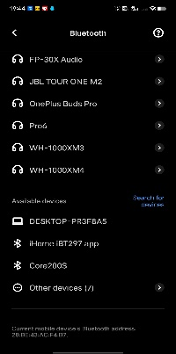
Narration: …at which point it enters pairing mode  Title Slide: NONE  Music: None  Motion: Long press the headset on button to enter pairing status | 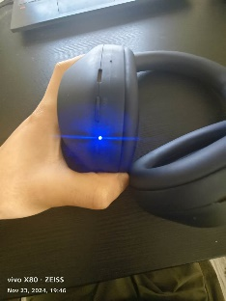
Narration: …click on pairing and you're done.  Title Slide: NONE  Music: None  Motion: press on pairing and you're done. | 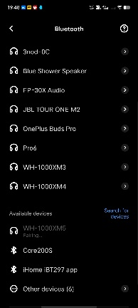
Narration: …I hope your headset successfully connected to their cell phones. Thanks.  Title Slide: NONE  Music: None  Motion: Speak to the camera. | End of the video.

